Day 1 : 09/25/2019

1. Download jekins – general package
2. C:\Jenkins_Software
3. Java -jar jenkins.war
4. To change port – java -jar jenkins.war ---httpPort=8081

To reuse installed jenkins / change home path

Set JENKINS_HOME=<installtion_dir>/home

1. Java -jar jenkins.war

<http://localhost:8080>

e12b0fd5700643c38ff262df894a2c92

Use password from cmd prompt . and install suggessted plugins.

1. Java -jar jenkins.war

To create new user

Manage Jenkins – Manage users – Create user - < enter details> - create user .

To enable sign up

Manage Jenkins – Configure Global Secutiry – Enable sign up – save – apply

Or

Jenkins_Home_path – Config file – open with wordpad – set it to false

<disableSignup>true</disableSignup>

Global security Options

1. Allow anonymouus read access -to view already created jobs
2. Matrix secutiry – granular security for particular user.
3. Project based matrix secutiry – granular secutiry at prject level

System log

1. To view logs of Jenkins from Start time of jenkins.
2. Can be backed up and nullified.
3. Log location can be configured to other server.

Build Jobs 1 – With Windows bash commands

echo "BUILD_NUMBER" :: %BUILD_NUMBER%

echo "BUILD_ID" :: %BUILD_ID%

echo "BUILD_DISPLAY_NAME" :: %BUILD_DISPLAY_NAME%

echo "JOB_NAME" :: %JOB_NAME%

echo "JOB_BASE_NAME" :: %JOB_BASE_NAME%

echo "BUILD_TAG" :: %BUILD_TAG%

echo "EXECUTOR_NUMBER" :: %EXECUTOR_NUMBER%

echo "NODE_NAME" :: %NODE_NAME%

echo "NODE_LABELS" :: %NODE_LABELS%

echo "WORKSPACE" :: %WORKSPACE%

echo "JENKINS_HOME" :: %JENKINS_HOME%

echo "JENKINS_URL" :: %JENKINS_URL%

echo "BUILD_URL" ::%BUILD_URL%

echo "JOB_URL" :: %JOB_URL%

C:\Jenkins_Software>java -jar jenkins.war

Day 2 :

1. Build

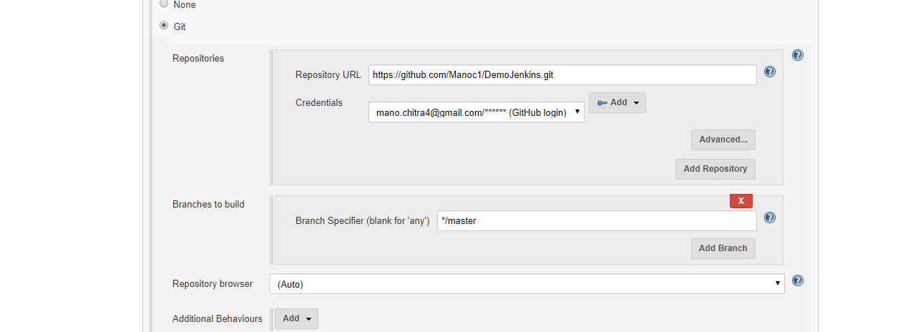

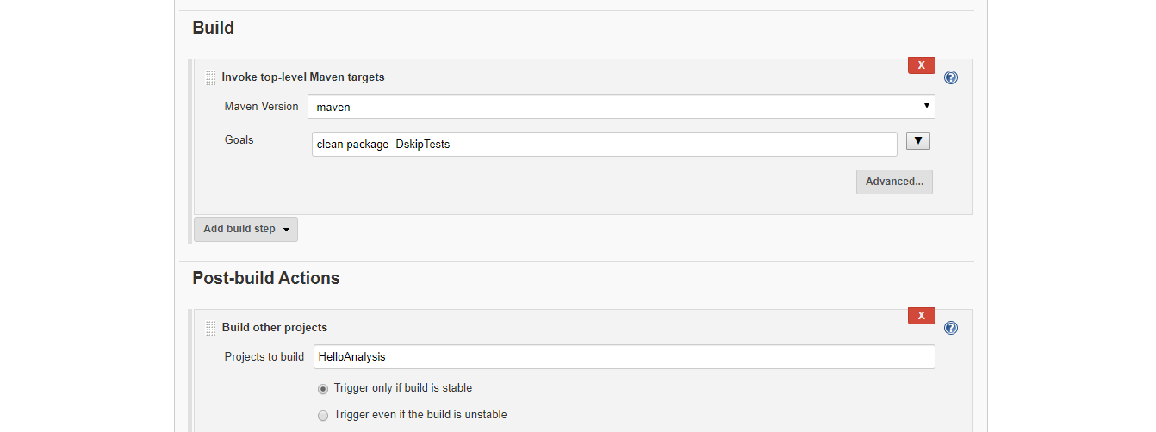

1. Analysis

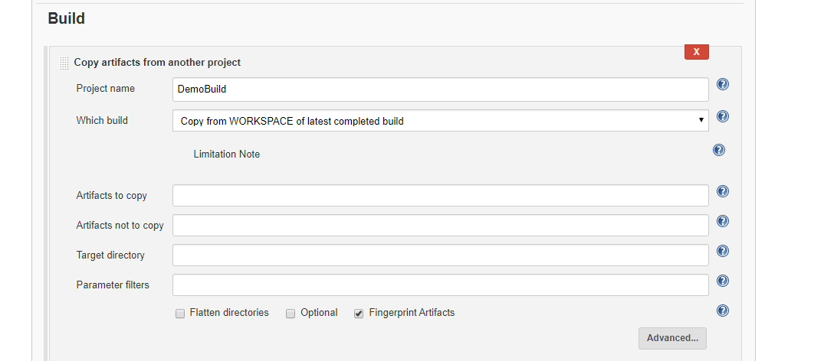

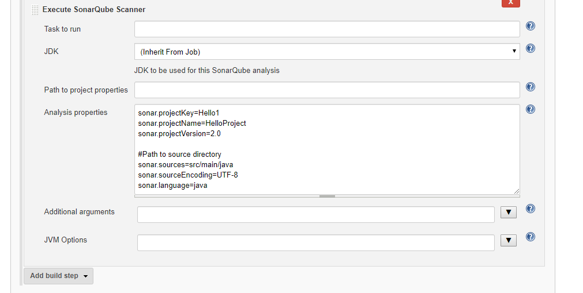

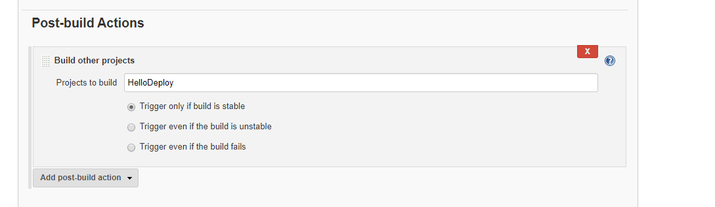

1. Deploy

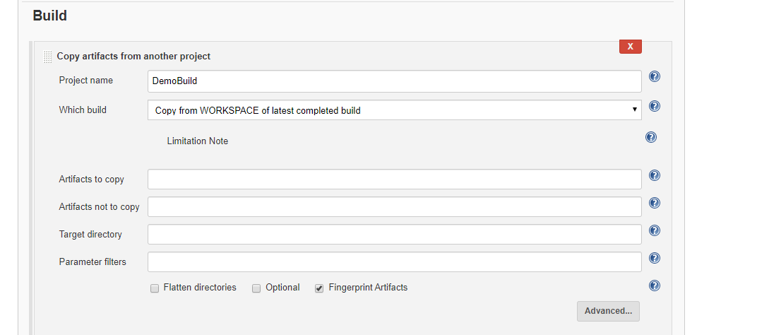

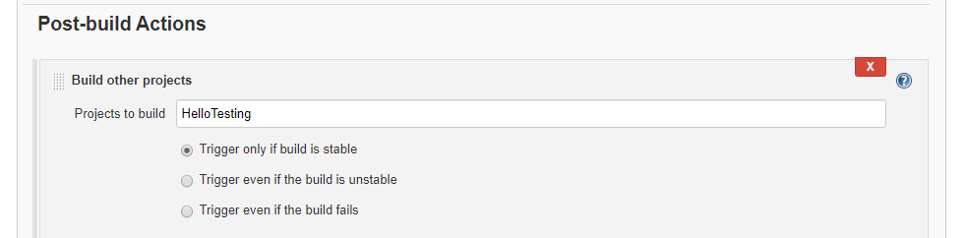

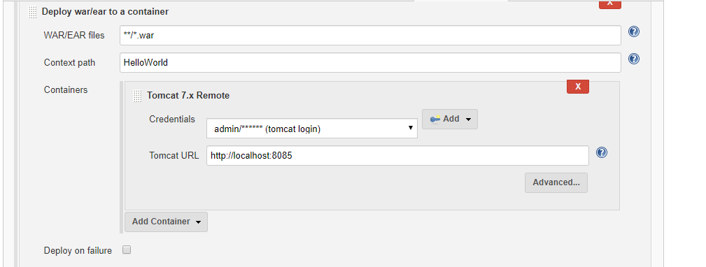

1. Testing

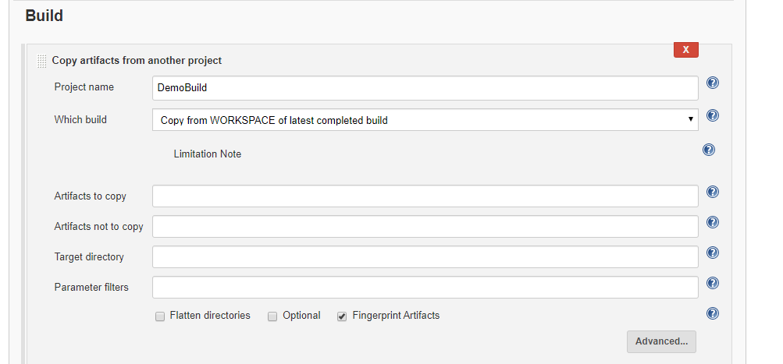

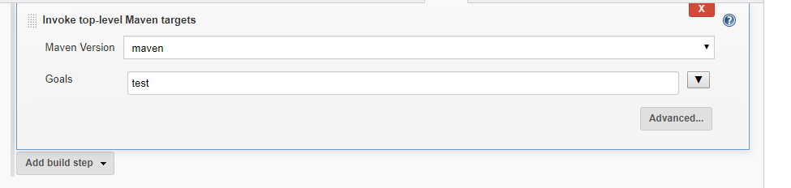

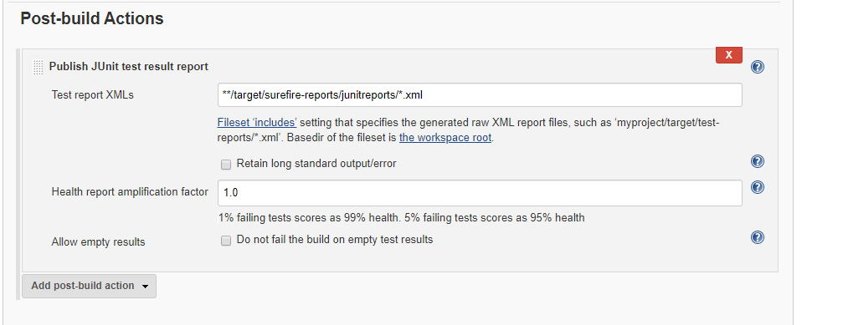

Pipeline

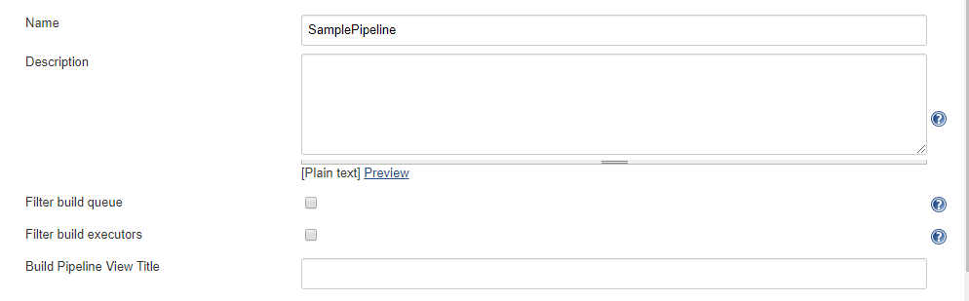

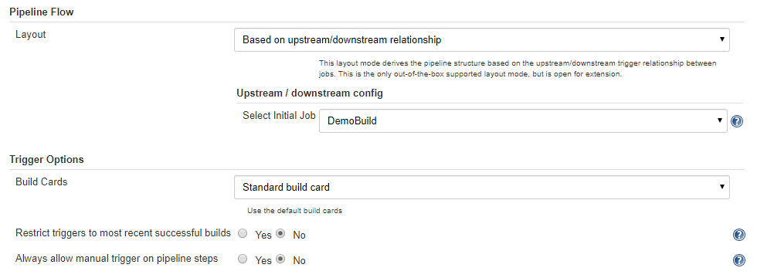

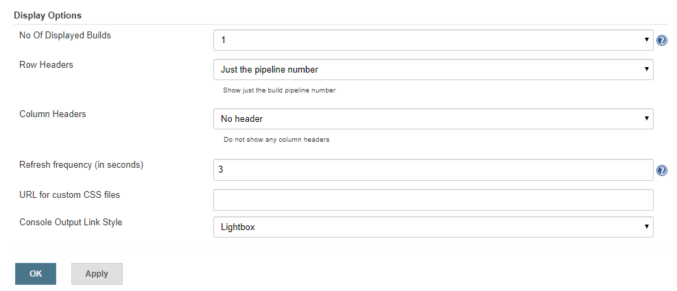

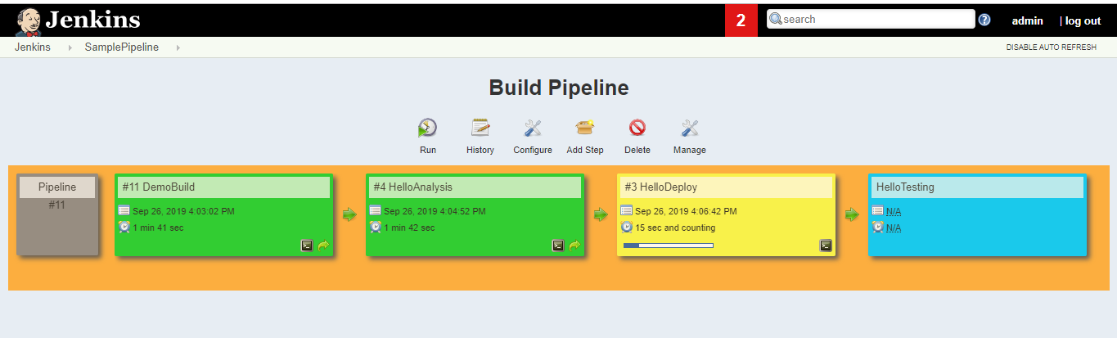

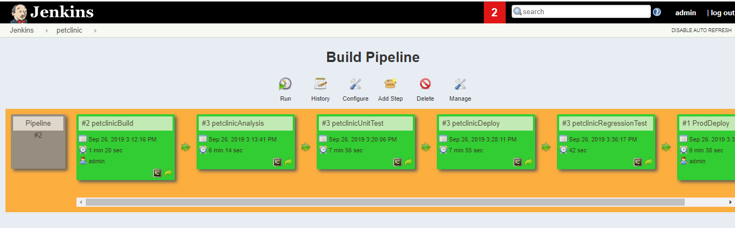

Regression test

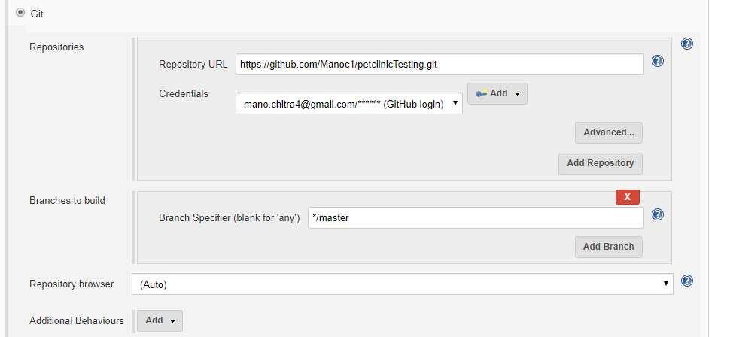

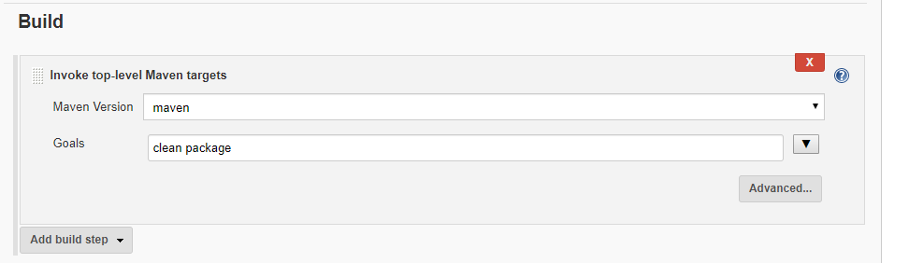

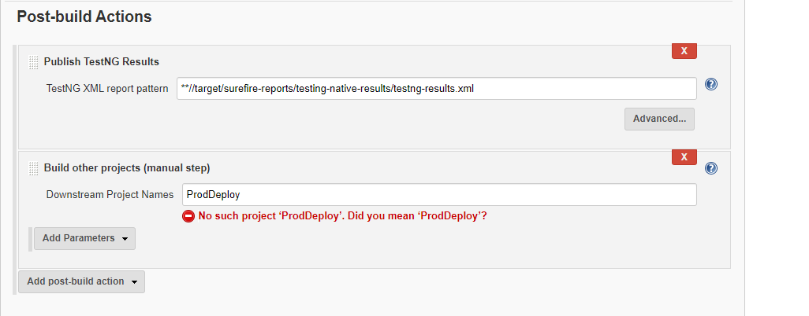

Automatic Trigger of pipeline

1. If there is commit in GIT then pipeline will be triggered

